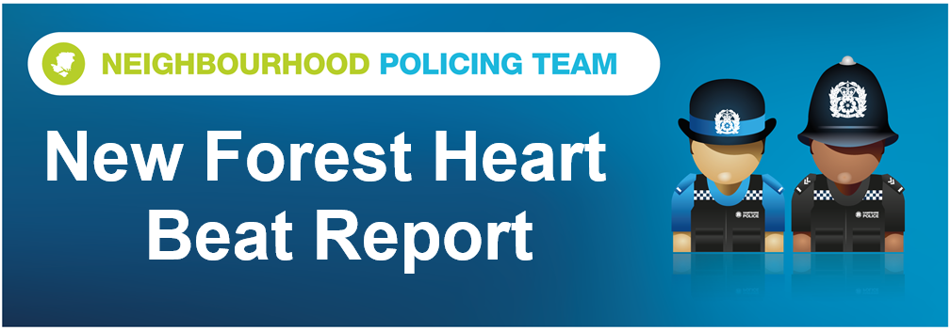

Hello and welcome to the August 2026 Beat Report for the New Forest Heart area. Your team is PC 24901 Mark ROBERTS, PC 27901 Stuart READHEAD and PCSO 14495 Richard WILLIAMS.
In September join us at one of our Beat Surgeries across the area – On Tuesday 8th September we will be at the Bartley Post Office at 9am and then in the Happy Cheese Pub in Ashurst with the Ashurst and Colbury Neighbourhood watch team at 11am. Then on Wednesday 16th September we will be at the Lyndhurst Parish Council office in the Community Centre in the village from 11am and then an hour later at midday on Brookley Road in Brockenhurst, just opposite Tesco.
Seven vehicles were broken into during August, one was parked in the Longslade Heath car park, one at Andrews Mare and another on a driveway in Cadnam. Four cars were also targeted on the same night in the car park of the Rhinefield House Hotel just outside Brockenhurst.
Four bicycles were stolen this month and all of them from Brockenhurst. Even though they were all locked and secure three of them were taken during the day on the busy Brookley Road, the other was taken overnight from on the pub car parks in the village. The good news is that a male has been arrested and charged for one of those thefts as well as a series of shopliftings in the village.
Other shopliftings this month included a large amount of meat from the Co Op stores in Ashurst and in Brockenhurst and a putter from the pro shop at Brook golf club.
Also in August a business in Exbury and a house in Brockenhurst were broken into and jewellery and gold coins stolen - the investigations into both of those burglaries are still underway. That’s the same for the two burglaries in Cadnam that happened on the same night at the end of the month where expensive tools and machinery were stolen from a garage and a shed.
The building site on Whartons lane in Ashurst was entered this month and although nothing appears to have been stolen criminal damage was caused to the gate and its lock. Fuel from a petrol station in Cadnam has also been taken in an incident known as making off without payment.
Roundhill Campsite suffered criminal damage just before the bank holiday weekend where black paint was thrown onto a motorhome and the toilets – if you saw this happen or have any information that would help us identify the person who did it then please email either PCSO Williams or PC Roberts
The main concerns in August of course were the fires across the Forest especially on the A31 and at Boltons Bench – we have been out on patrol across the Forest helping our colleagues keep the impact of these fires to an absolute minimum and your help with that has been priceless. Please if you see any suspicious activity anywhere please call us immediately. And if you don’t have the what3words APP on your phone now is the time to download it. It’s free and it provides us with your exact location which in the Forest is so useful. Thank you
Stay safe everyone
richard.williams@hampshire.police.uk
07554 775469

mark.roberts.2@hampshire.police.uk
07392 314340



