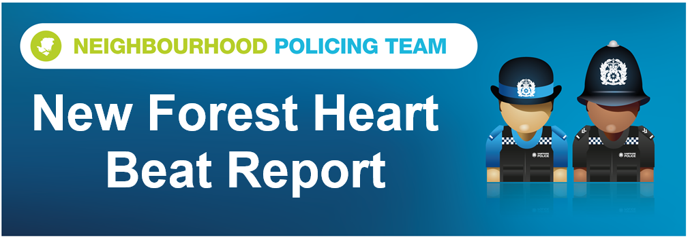

Hello and welcome to the May 2025 Beat Report for the New Forest Heart area. Your team is PC 24901 Mark ROBERTS and PCSO 14495 Richard WILLIAMS.
In June please join us at one of our Beat Surgeries –
On Tuesday 3rd June we will be with the Ashurst and Colbury Neighbourhood Watch team at the Happy Cheese in Ashurst at 11am and then an hour later at midday we will be on Brookley Road in Brockenhurst opposite Tesco.
On Thursday 5th May we will be at the Bramshaw Village Stores at 8am, at 9am outside the Post Office in Bartley.
Our next Walking in Partnership Beat Surgery will be at 9am on Saturday 7th June at the BLACKWATER CAR PARK, SO42 7QB or the W3W are stops.crinkled.cosmetic. Forestry England host guided walks throughout the Forest and this is the fifth time we have joined them for these events that are aimed at encouraging solo walkers and those people who don’t feel comfortable walking alone. We hold several Beat Surgeries every month and they are your opportunity to ask us about Policing in your area and they give us the chance to share with you the latest safety and crime prevention advice. If you want more information please email richard.williams@hampshire.police.uk
Our Beat Surgeries last for 30 minutes, unless demand is high of course, but as we always say if you can’t come to any of these meetings you can always call or email us, but to report a crime or any anti-social behaviour dial 101 or go the Hampshire and IOW Police website. Of course if it’s an emergency always call 999.
We are also holding a SECURITY BIKE MARKING SESSION between 09.00 and 11.00 on Sunday 8th June in the car park at Lyndhurst Police Station. Bring your bikes to us and we will mark and register them for free. Thanks as always to New Forest District Council who pay for the kits and do all the necessary paperwork for us.
Firstly an update on an incident we told you about last month – a man from Southampton was arrested at the beginning of May in connection with a theft from Careys Manor Hotel in Brockenhurst on 10th April. He has been released on Police bail while the incident is invested further.
This month’s thefts include 10 shopliftings and again we have identified suspects for just over half of them and we are hopeful that we will identify the others soon. Eight of the shopliftings were at the Co Op in Brockenhurst, one was at the Tesco in Lyndhurst and the other was at the Courtesy Filing Station at Cadnam where champagne was stolen. A credit card from a pub at Ower, a range finder from a bag at Paultons Golf Course, diesel from a site in Cadnam and a saddle bag from a bicycle parked up on the High Street in Lyndhurst have also been stolen.
Two houses were burgled in May – one in Minstead and the other in Woodlands and a workshop on a site in Bartley was also broken into and several items stolen. If you want any advice on how to keep your homes and outbuildings safe and secure please email richard.williams@hampshire.police.uk and we will answer any questions you might have.
Five vehicles left in New Forest car parks have been broken into this month – the areas targeted were laybys on the Roger Penny Way and at the Holmsley Pass, the Knightwood Oak and Bratley View car parks and the car park at the Longdown Dairy Farm. Handbags and wallets were stolen so please take them with you.
And ten bicycles have been stolen in May from campsites in the Forest - two from Sethorns, one from Ocknell, four from Hollands Wood (all on the same night) and one from Longmeadow. Two bicycles were also stolen from the car park of a hotel in Brockenhurst, and an attempt was made to steal a bike from inside a car parked at an hotel in Emery Down but the car alarm did its job and nothing was taken.
Also this month we had reports of some damage that has been caused to a scheduled monument in the area – we don’t want to give the location away but someone has been digging on the mound which is the site of an Iron Age Fort. A catapult was also used to damage windows of houses on Colbury Lane.
May’s OP MOUNTIE took place at lunchtime at the Kings Hat Inclosure on the road into Beaulieu from Ipley Cross. Hopefully most people are now aware that OP MOUNTIE is our multi agency approach to reducing speed and animal accidents across the New Forest and this month we were joined by Forestry England and the New Forest Roads Awareness Team. There were three reasons why we held a lunchtime session this month. The first is in response to you telling us when and where you witness the worst speeds and Kings Hat is always high on that list. The second is that there are a mix of stallions and foals out on the Forest at the moment and that means that extra care is needed. And the third is that we had two animal fatalities on the Forest during daylight hours this month.

This month we stopped seven vehicles with the highest speed being 54mph – remember the limit in the Forest is 40mph. Thanks to all those drivers who did stick to the limit – again the vast majority – and please drive carefully.

richard.williams@hampshire.police.uk
07554 775469

mark.roberts.24091@hampshire.police.uk
07392 314340



