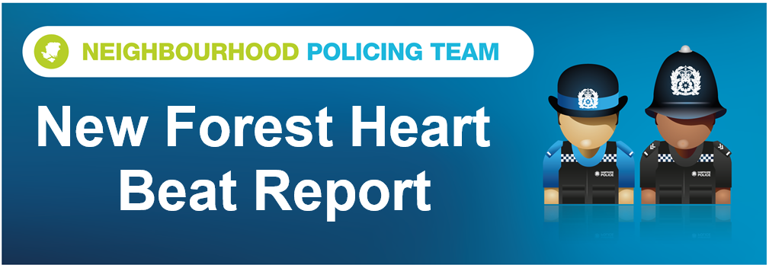

Hello and welcome to the May 2026 Beat Report for the New Forest Heart area. Your team is PC 24901 Mark ROBERTS, PC 27901 Stuart READHEAD and PCSO 14495 Richard WILLIAMS.
On Saturday 6th June we will be joining our Sergeant 20401 Rob Blake for the MEET THE TEAM Beat Surgery in Totton. The team travels on bicycles through the town starting at Hangar Farm at 3pm, then moving on to the West Totton Centre for 3.30pm and finishing up at the Bartley Skate Park at 4pm
On Monday 15th we will be at the Bramshaw village store at 8am and then at Bartley Post Office at 9am, on Tuesday 16th at 11am we will be at the Happy Cheese Pub in Ashurst with the Ashurst and Colbury Neighbourhood watch team and an hour later at midday on Brookley Road in Brockenhurst, just opposite Tesco.
The following day, Wednesday 17th June you can join us at the Lyndhurst Parish Council Offices at 11am.
We are also holding another one of our SCAM BUSTING talks at 2pm on Thursday 25th June at the Lyndhurst Community Centre in the main car park in the village.
Our Beat Surgeries last for 30 minutes, unless demand is high of course, but as we always say if you can’t come to any of these meetings you can always call or email us, but to report a crime or any anti-social behaviour dial 101 or go the Hampshire and IOW Police website. Of course if it’s an emergency always call 999.
The number of sheds, garages and outbuildings broken in to increased in May, with eleven reported to us in Ower, Brockenhurst, East Boldre, Woodlands, Winsor and Lyndhurst where a bicycle was stolen while power tools and gardening equipment were the other items taken from across the Forest. Over the last six months, in partnership with New Forest District Council, we’ve been handing out SelectDNA Forensic marking kits to residents of the New Forest. These kits allow you to put a security mark on your valuable items including tools, trailers, vehicles and so on and if they are ever stolen and then recovered by Police we can return them to you. The kits are also a useful deterrent to would be thieves. If you have been given one of these kits can we ask you to register it and start marking your property as soon as possible please. They are a really useful tool against theft but only if they are used by you to mark your property. And if you would like one of the kits please email richard.williams@hampshire.police.uk and we will send you one and remember they are free of charge.
A quad bike and a Ford Ranger were also stolen in May from addresses in Ower and Woodlands – the Ranger has been found and recovered by the owner but we are still looking for the quad bike. A generator was stolen from a welfare van on a site just outside Lyndhurst, kitchens waiting to be installed at a different site on the outskirts of Totton were also stolen as was a bicycle that was left outside the Tesco in Brockenhurst for no more than 10 minutes.
There have been four shopliftings, all of them from the Tesco on the High Street in Lyndhurst, plants were also stolen from a nursery in East End and Forestry England car parking signs have been stolen or damaged in several car parks across the Forest. Again if you have any information that will help us identify who is responsible then please let us know.
The reversing camera and light were taken from a motorhome in Ashurst campsite and a car was broken into overnight in the car park of the Copythorne Scout Hall while an overnight camp was taking place. Number plates were stolen from a car in Woodlands, a laptop bag from a car parked overnight in a hotel car park in Cadnam and the catalytic converter was cut off a car parked on a driveway in Brockenhurst.
May’s Op Mountie was again another example of how the vast majority of drivers travel at or below the 40mph speed limit. BUT we did stop four drivers who were doing 46, 47, 49 and 60 mph even though a group of ponies including two foals spent all morning within 200 metres of our position at the Matley car park on the road out of Lyndhurst towards Beaulieu.
Op Mountie is our multi agency operation where we work with Forestry England, the New Forest National Park Authority and the New Forest Roads Awareness Team in a bid to reduce sped and animal accidents across the Forest. The message this month is a simple one, foals are being born and stallions are back on the Forest making next year’s foals so please take even more care than usual.
At the end of May we received reports of some unusual and concerning behaviour in the fields along Chineham Road in Bartley. On one occasion a horse in one of the fields was injured and had to receive treatment from a vet and on another occasion taps were left on in the field which caused extensive flooding. If you know anything that help us identify those responsible or if you see anyone behaving suspiciously in the area then please contact PCSO Williams on the email provided or call 101 and quote the incident number 44260237632. Thank you
Finally can we remind you, again, about the need to take all of your valuables with you when you leave your vehicle unattended anywhere and don’t hide them in the boot either because you never know who is watching you. The holiday season brings thieves as well as visitors to the Forest so please spread the word and if you would like one of our NO VALUABLES HAVE BEEN LEFT IN THIS VEHCILE cards email richard.williams@hampshire.police.uk and we will send you one.
Stay safe everyone
richard.williams@hampshire.police.uk
07554 775469

mark.roberts.2@hampshire.police.uk
07392 314340



